

**Pre-Lab 5: Add Bees to the Maze**

Name: Socheath Sok,

Class: EE 346 L

Section 6, T/Th

Date: October 30, 2018

**Modified Maze**

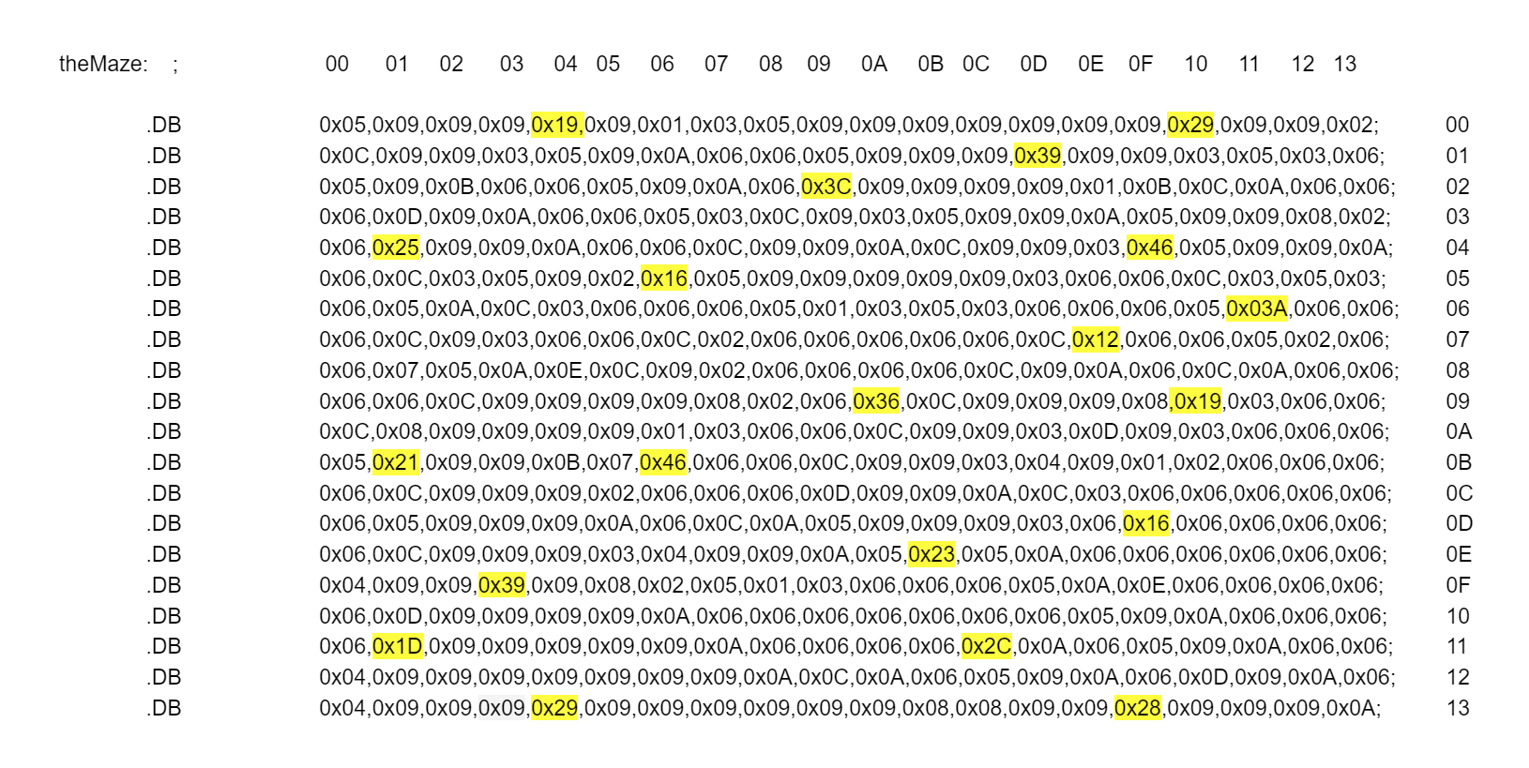

**Questions:**   
1. The following code is used to initialize the Z pointer for indirect addressing:  
 ldi ZH, high(table<<1)  
 ldi ZL, low(table<<1)  
 1. Why are two registers required to initialize the pointer to the correct address?

Each pointer register has 8 bits but an address has 16 bits, so two registers are needed to initialize the pointer to the correct address.

2. If the address for the start of “table” is at 0x 0A2C and the data that is saved at that

flash address is 0x49 and 0x8A, what will the value in the Z register be (for ZH and

ZL) after the two lines of code are executed? Explain.

Z-register deals with the address and not the value, so from the instruction, the address need to be shifted 1 bit to left. This make ZH = 14 and ZL = 58.  
3. What does the expression table<<1 represent? Describe what action is taken or what

it does with the example values from part b.

table<<1 means shift the table address 1 bit to the left.

2. table: .DB 0b01000001 0b01100000 0b00100011 0b00000001  
 After initializing the z pointer to the start of “table,” the following code is executed:  
 clr r1   
 add ZL, r0 // ZL = 0x03 + 0xD7  
 adc ZH, r1 // ZH = 0x00  
 lpm r16, Z  
 1. If the value in r0 is 0x03, and the beginning address for “table” is 0x00D7, what is the

value that is in ZH and ZL?

ZH = 00, ZL = DA  
 2. According to the code above, where is the data being loaded to (the destination for

the data) in the lpm instruction?

r16